**Case Study 5**

**Profile of M/s SPI**

|  |  |
| --- | --- |
| Name of the Enterprise | **M/s SPI** |
| Managing Director | KR |
| Constitution | Sole Proprietary |
| Factory Address | Bhongir |
| Established | 2015 |
| Line of Activity | Manufacturing of disposable paper plates |
| SSI Registration No. |  |
| GST |  |

1. **Line of Activity**

Entrepreneur engaged in Manufacturing of disposable paper plates

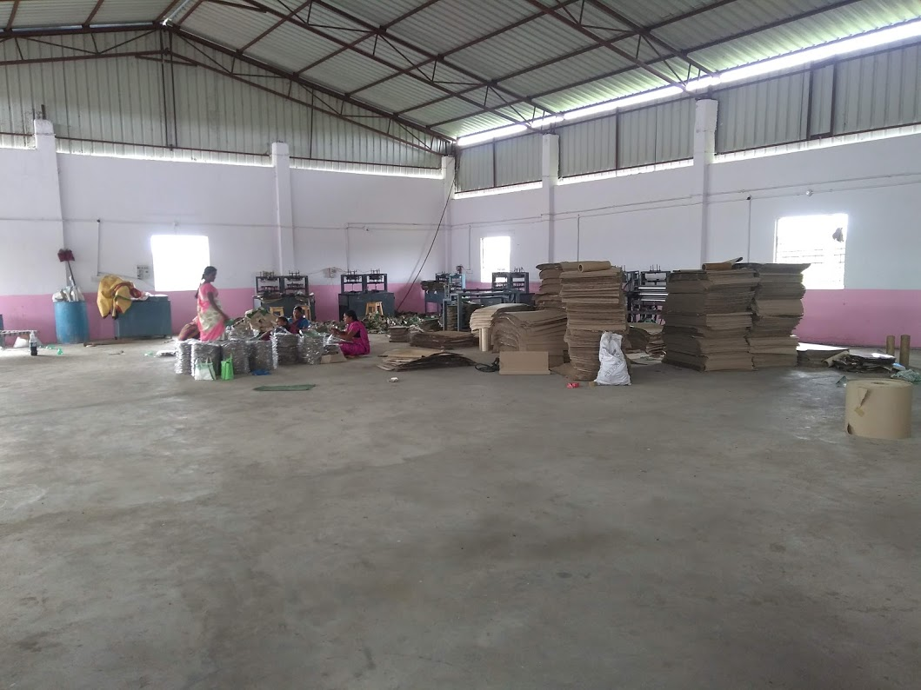

1. **Managerial Competencies**

The promoter Mrs. R is a woman of moderate academic background and she has got knowledge of the Manufacturing activity and she is supported by here husband Sri. K. Mallesh for marketing and distributuon for the product, he has 15years of experience in the marketing and distribution of the product.

1. **Machinery**

The firm has semi-automatic machinery which include corrugated cutting machines, lamination machine, various dies etc.

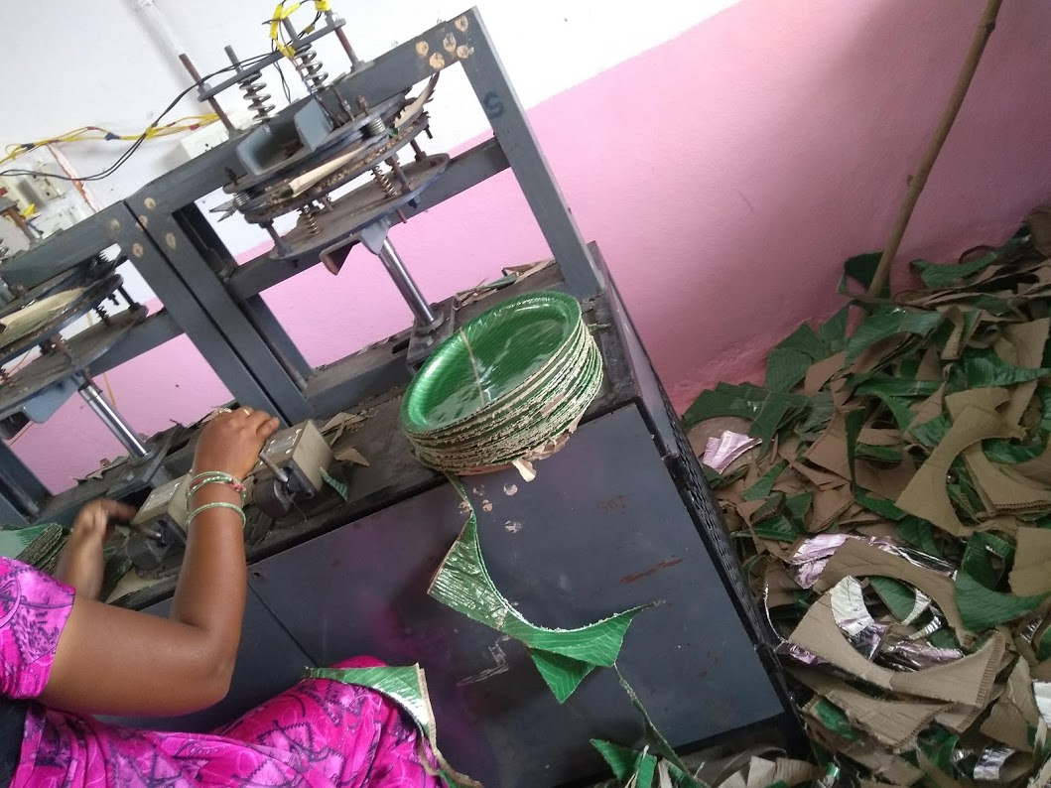

1. **Marketing**

The applicant has enough capacity to cater the requirement of the market in and around Koritikal village, The unit has a good customer base in that region. The customer has decent knowledge of the market and its potential.

1. **TIHCL Intervention**

The entrepreneur has visited TIHCL for revival of the unit and seeking support to clear the irregularities in his term loan account. The unit was banking with Andhra Bank, Koratikal Branch. The unit was sanctioned with ₹3.4 million of term loan and ₹0.3 million of working capital. TIHCL has diagnosed the enterprise and identified following reasons of sickness:

* Investment on construction of Industrial shed was higher than projected.
* Sanction of inadequate Working capital.
* Part of working capital was utilized for construction of shed.
* Sale proceeds are not being routed through Bank account and operations in OCC A/c are not commensurate with the Business turnover. Non submission of stock statements.
* Additional burden to meet CGTMSE fee.
* Non receipt of PAVALA VADDI reimbursement to the extent of Rs.3.95 lakh.

With the intervention of TIHCL the working capital limits were enhanced from ₹0.3 million to ₹0.9 million by Andhra Bank. TIHCL has given margin loan of ₹0.12 million

|  |  |  |
| --- | --- | --- |
| Key Indicators | Pre-Revival | Post TIHCL Intervention |
| No of EMIs pending with primary lender | 6 | 0 |
| Capacity Utilization | 60% | 80% |
| Turnover | ₹3.4 million | ₹ 6.0 million |
| Employment | 10 | 10 |

1. **Labour Status**

|  |  |  |
| --- | --- | --- |
| Gender | Skilled | Unskilled |
| Men | 02 | 0 |
| Women | 06 | 02 |
| Total | 08 | 02 |

Livelihood: At 80% of the capacity they have employed 10 workers and their families are dependent on this enterprise which is around 50 individuals including entrepreneurs. The employed workers are sufficient to run at full capacity the idle time of workers will be reduced.